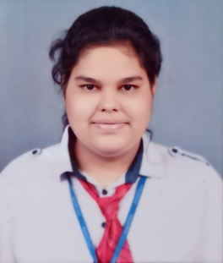 

RADHIKA AGARWAL

Radhikaagarwalbly03@gmail.com

+91 7310520181

**CAREER OBJECTIVE**

To explore and excel in a dynamic work environment where I can utilize my skills, learn new things, and contribute to the growth of the organization.

**ACADEMIC QUALIFICATION**

|  |  |  |  |  |
| --- | --- | --- | --- | --- |
| **Course** | **Name of the Institute** | **Board/University** | **Year** | **Percentage** |
| **B.Com(H)** | IIMS | Invertis University, Bareilly | 2022-25 | 77%  (Till 3rd Sem.) |
| **Senior Secondary** | St. Maria Goretti Inter College | CBSE | 2022 | 83.2% |
| **Secondary** | St. Maria Goretti Inter College | CBSE | 2020 | 78.7% |

**SUMMER INTERNSHIP TRAINING**

**Name of Organization: ‘Hands Vs Hunger Welfare Society’**

**Profile:** Team Coordinator of my team members

**Duration**: 1 month

**Key Learning:** Leadership skills, Canva , VN, MS Excel, Team work, Communication skills

**OTHER INTERNSHIPS( OFFLINE )**

**Name of Organization: ‘Agarwal agencies’**

**Duration:** 2 months

**Profile:** Inventory Control Manager, HR

**Key Take Away:** Communication skills, Excel skills, Marketing strategies, MS Office

**Name of Organization: ‘Corizo’**

**Duration:** 1 month

**Profile:** Marketing intern

**Key Take Away:** Networking, Digital marketing

**INDUSTRIAL VISIT**

**Name of organization**: ‘Parle Biscuits Pvt. Ltd., Pantnagar’

**INDUSTRIAL VISIT:**

**Key Take Away**: I learned a lot about the manufacturing process of biscuits and the scale of their operations. It was fascinating to see how they ensure quality control and maintain efficiency in their production. I also gained insights into their marketing strategies and how they have built such a strong brand presence.

**Name of organization:** ‘ITC printing and packaging unit, Haridwar’

**Key Take Away:**I learned a lot about the printing and packaging process of various types of products and other FMCG goods in the industry. It was fascinating to see how they ensure quality control and maintain efficiency in their production. I also gained insights into their marketing strategies and how they have built such a strong brand presence of the packaging unit

**CERTIFICATE PROGRAMME/ WORKSHOPS/CONFERENCES/WEBINAR**

* Attended online Alumni Guest Lecture titled “Skill Development and Youth Empowerment”organized by Department of B.COM. Invertis University, Bareilly,April,2023
* Certificate of Silver Zone Quizs
* Certificate of participation:5thInternational conference on Recent Advances and Technology, December,2023
* Attended online Alumni Guest Lecture titled “Empowering Communities through NGO” organized by Department of B.COM. Invertis University, Bareilly, February,2024
* Attended Mind awakening session titled “Yoga and meditation” organized y Department of B.COM., Invertis University, Bareilly, March,2
* Certificate of participation workshop of crochet art

**ACHIEVEMENTS**

* **Sketching:**

Skilled in freehand sketching and illustration using mediums like pencil and charcoal. This can be valuable for advertising, graphic designing.

**KEY ATTRIBUTES**

* Proficient in MS Excel, PowerPoint, Canva
* Skilled in video editing and production
* Knowledgeable in marketing strategies
* Basic knowledge of MS office

**PERSONAL PROFILE**

**Name:** Radhika Agarwal

**Date of Birth:** 02/12/2003

**Gender:** Female

**Father’s Name:** Sandeep Chandra Agarwal

**Mother’s Name:** Mamta Agarwal

**Language:** English & Hindi **No.:** 7310520181

**Email id:** radhikaagarwalbly03@gmail.com

**Address:** 9/ MandleVihar , I.V.R.I. Road Bly, U.P.

**DECLARATION**

I hereby declare that the information provided above is true and the best of my knowledge.

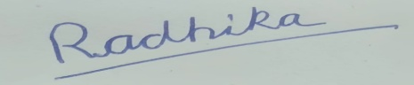

RADHIKA AGARWAL March/31/2024